Research Project for GHS
(length: 4 to 6 pages including references, written by the candidate; minimum font size: 11pt)

Name
Project Title

Background (max 1 page)
Click here to enter text.

Hypothesis & Aims

Click here to enter text.

Methodology & Research Plan (Specify the criteria for selection of patients/volunteers, give detailed information on evaluation strategy and the models/paradigms that will be used.)
Click here to enter text.

Possible Pitfalls
Click here to enter text.

Timetable (important, graphic representation of the tasks of the whole PhD to be evaluated on a yearly basis)
NOTE: doctoral students for FKIII (PhD in Clinical Sciences) should also clearly indicate the respective time periods of clinical and research practice.
Example:
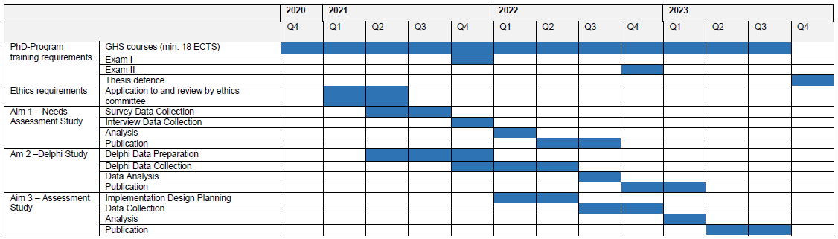

Collaborators (Who is doing what?)

your specific tasks as PhD
Name, role (thesis advisor) and tasks
Name role (co- thesis advisor) and tasks
Name role (co- referee) and tasks
Name role (…..) and tasks
Name role (…..) and tasks

Significance
Click here to enter text.
Publications plan
Not all types of articles are recognized for your PhD. Please see the publication requirements on our homepage: Publications GHS
Subject or title of publication | Authorship (first or second) | Publication type* | Journal | Timeframe (Q and year)
Click here to enter text. | Click here to enter text. | Click here to enter text. | Click here to enter text. | Click here to enter text.
Click here to enter text. | Click here to enter text. | Click here to enter text. | Click here to enter text. | Click here to enter text.
Click here to enter text. | Click here to enter text. | Click here to enter text. | Click here to enter text. | Click here to enter text.
* Please indicate the type of publication: (OA) = original article; (SR) = systematic review; (MA) = meta-analysis; (NR) = narrative review

References
Click here to enter text.

Application to Ethics Committee ☐ Not applicable
☐ Applicable
If applicable: ☐ Submitted
☐ Approved

